***React Native vs Flutter***

***React Native:***

- **React Native** is an [open-source](https://en.wikipedia.org/wiki/Open-source_software) [mobile application framework](https://en.wikipedia.org/wiki/Application_framework) created by [Facebook](https://en.wikipedia.org/wiki/Facebook) in 2015. It is used to develop applications for [Android](https://en.wikipedia.org/wiki/Android_(operating_system)) & [iOS](https://en.wikipedia.org/wiki/IOS) by enabling developers to use [React](https://en.wikipedia.org/wiki/React_(JavaScript_library)) along with native platform capabilities.

***Flutter:***

- Flutter is Google’s mobile app development SDK that allows your product to target both Android and iOS platforms simultaneously, without the need to maintain two separate codebases.

While native apps offer superior user experience, cross-platform and hybrid designed to save time and cost along with providing faster time-to-market.

Now, we will compare both the frameworks corresponding to the mentioned points:

* ***Programming Language:***

1. React Native lets you develop an app using JavaScript. As JavaScript is widely used by most web developers, it’s easy to adopt the React Native framework.
2. Flutter uses Dart. Dart is a programming language for fast apps on multiple platforms. Dart also has a great feature set but it’s rarely used and less known in the developer community.

* ***Technical Architecture:***

1. React Native, however, uses the JavaScript bridge to communicate with native modules, which results in poor performance.

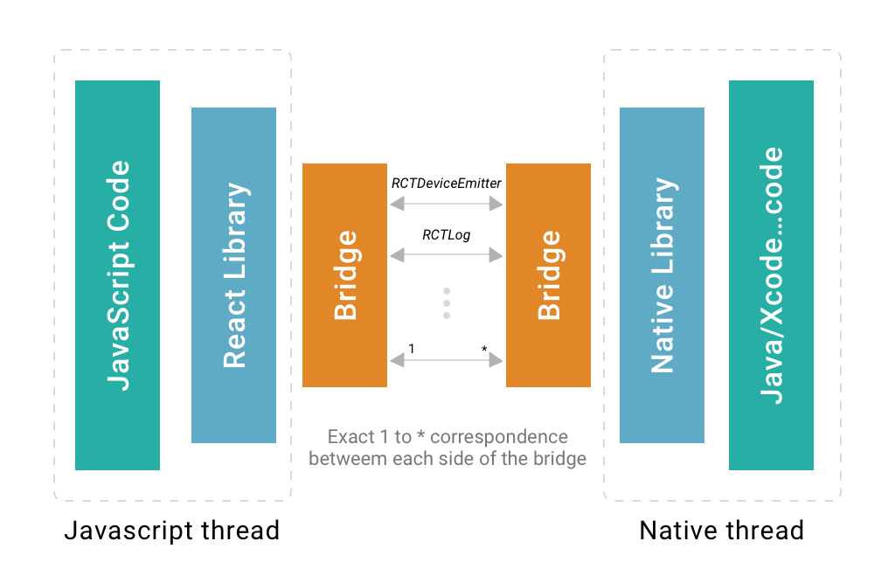

1. Flutter engine has most of the native components in the framework itself and it doesn’t always need a bridge to communicate with the native components.

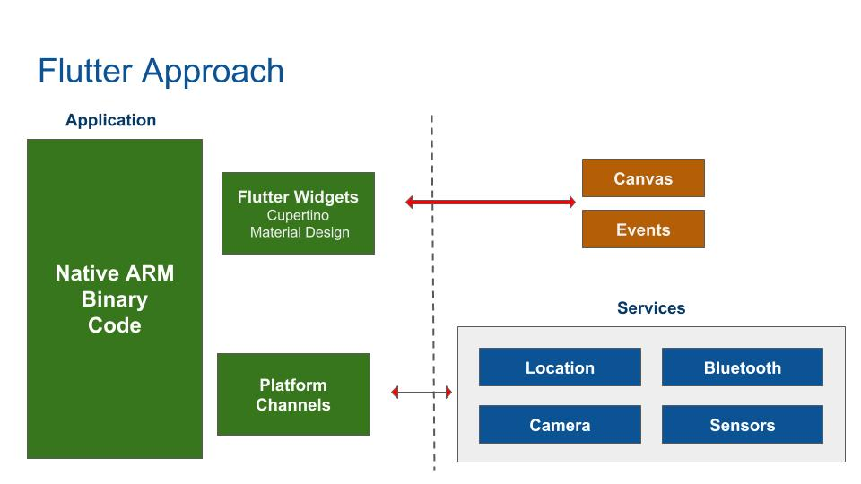

* ***Ecosystem:***

1. React Native is originated a bit early and has the marketplace.
2. Flutter is certainly behind React Native when it comes to the Ecosystem, as React Native is well established with tons of packages already. However, Flutter is catching up with a tremendous pace, and many core packages for mobile development are available for public use.

* ***Stability & Flexibility:***

1. React Native offers seamless user experience via directly communicating with the native platforms. It is enjoying the first position in the list of cross-platform app development tools in the market.
2. Flutter offers a rich set of customized widgets to build attractive experiences. It is still trying to make its position in the market due to the recent stable release.

* ***IDEs & Text Editors:***

1. In terms of IDE support, RN developers are free to use any text editor or IDE of their choice like Atom, Visual Studio Code etc.
2. Dart is not a common programming language and there is a lack of support for it in many IDEs and text editors.

* ***UI components & Development APIs:***

1. The core React Native framework provides just UI rendering and device access APIs. In order to access most of the native modules, React Native has to rely on third-party libraries. React Native is too much dependent on third-party libraries.
2. Flutter framework is bundled with UI rendering components, device API access, navigation, testing, stateful management and loads of libraries. This rich set of components removes the need to use third-party libraries. Flutter also has [widgets](https://flutter.io/widgets/) for Material Design and Cupertino that allow developers to easily render the UI on both iOS and Android platform.

* ***Hot Reloading & Quick Modifications:***

1. React Native supports “Hot Reloading” that enables simultaneously running new code and keeping hold of application state, instead of recompiling. This makes development faster, instant, and efficient.
2. Flutter is not left behind. Introducing “Stateful Hot Reloading”, Flutter supports immediate reflection of changes without restart or in case of loss of application state.

* ***Community Support:***

1. The React Native community and resources have grown in size since the framework was launched. There is a community of React Native developers on[GitHub](https://github.com/react-native-community) and lots of meet-ups and conferences around the world.
2. The Flutter community is growing rapidly; yet, there are still not enough resources for developers to solve common issues.

* ***Performance*:**

1. React Native is popular for delivering excellent user experience on both the platforms.

1. Flutter has the extra advantage of reusing the code. Also, Dart compiles to ARM & x64 machine code for mobile, desktop, and backend. The C ++ engine works flawless and supports the language hence Flutter gains appreciation here.

* ***Development Time of An App:***

React Native and Flutter both are committed to providing faster time-to-market of an app. You can use third-party libraries and ready-to-use components to build an app. A customized and high-quality range of widgets helps build an app in lesser time than native app development.

* ***Here’s A Sought-after Summary:***

1. Choose React Native when you want to leverage the support from the stronger and mature community, native app performance, and popular JavaScript in developing cross-platform apps.
2. Choose Flutter when you want cross-platform, highly-attractive UI, excellent native performance, quicker time-to-market, and competitive advantage of using Dart in your programming environment.

|  |  |  |
| --- | --- | --- |
|  | React Native | Flutter |
| Language | JavaScript | Dart |
| Developers | Facebook | Google |
| Initial Release | 2015 | 2017 |
| Learning Curve | Easily adaptable for front-end developers as it uses JavaScript | Need to learn new language |
| Installation | Install easily through NPM | Installation requires some extra steps like setting paths |
| Architecture | Architecture depends on bridging resulting in poor performance | Complete & Independent Architecture |
| Native Performances | Good | Superior |
| Time-to-Market of App | Slower than flutter | Faster |
| Documentation | Up-to-date but imprecise | Precise, clear, up-to-date |
| Community | Huge & active community | Smaller community than React |
| Who Uses | Facebook, Instagram, Pinterest, Tesla, Walmart, Wix.com, Baidu Mobile, Artsy & so on | Alibaba, Google tea, Google Ads, App Tree, Reflectly |
| Ecosystem | Came bit early | Came after react native but its catching up speedily |
| Hot Reloading | Supported | Supported |
| Third Party Dependency | Rely on third party library | Removes the need of third party library |
| Testing | Testing is done using third party | Inbuilt testing support through modules |
| IDE Support | Free to use any editor | Lack of support |
| Advantages | More than 4 years in market with the ability to deliver native like experience | Simple, faster, elegant native apps using easy-to-use Flutter SDK |